**INHA UNIVERSITY IN**

**TASHKENT**

Design and Implementation report of a Website

for Online Car Shopping: MyGarage

**Group: Secret**

**Submitted by**

Azizov Nodirbek U1810260*

Abdulkhatov Abdulaziz U1810242

Akhmadjonov Azizjon U1810251

Khomitova Shakhzoda U1810295

Rakhimov Azizjon U1810187

Khilola Ergasheva U1710222



**Description:**

* Any member can register and view available products.
* Only registered members can purchase multiple products regardless of quantity regarding the wallet.
* Contact Us page is available to contact Admin for queries.
* There are three roles available: Visitor, User, and Admin.

Visitors:

* Can view all products;
* Can see contact page;
* Contact with admin;

Users (Customers):

* Have their own home page;
* Can view products available to purchase in the store;
* Can see purchased cars
* Have access to any page(beside of admin page);

Admin:

* Can view purchased product by customer (customer details will also be displayed);
* Can add products
* Can modify information about products
* Can remove sold products
* Can remove users from the site

Admin can ship the order to the user based on the order placed by sending confirmation mail.

**Web Pages details:**

* Home Page (index.php)
* Shop Page (portfolio-item.php)
* Media Page (media.php)
* Contact Us Page (contact-us.php)
* Admin Page (manage_admins.php)
* Login Page (login/index.php)
* Register (client login) Page (customer/index.php)

**Guideline**

* **HOME PAGE**

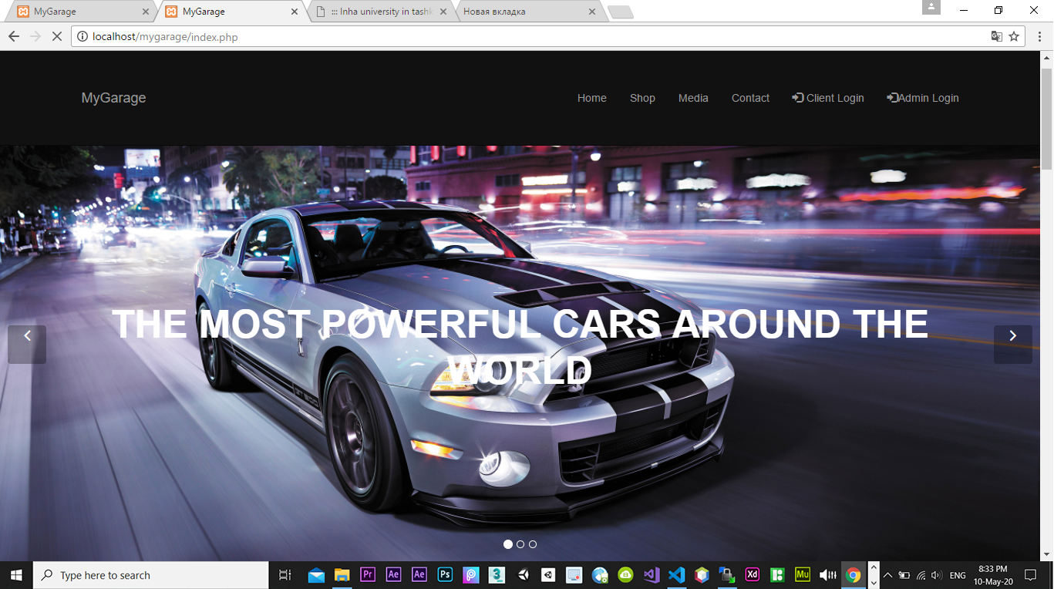

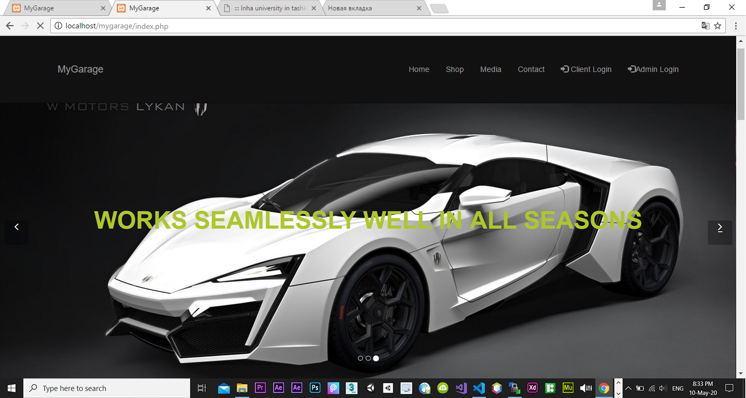

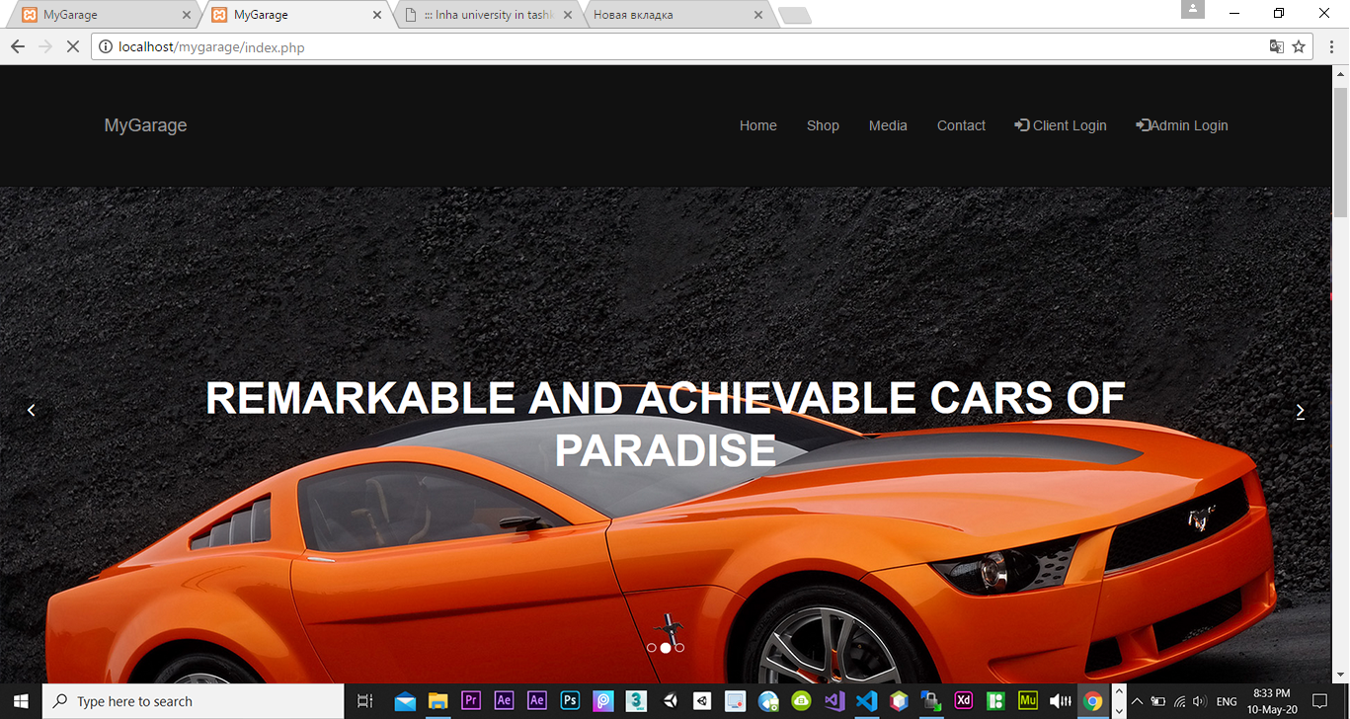

* First of all, every customer takes the first impressions from the home page, which leads to future trust for our site and us.
* So, we paid attention to our home page and tried to make it more attractive by using scrolling pictures (we called scrolling navbar, and some people call it “Karusel”). After clicking to the next picture, it starts changing pictures every 4s.
* In addition, we have used dark colors which we found as a symbol of luxury and speed.
* Also, visitors will pay attention on words which we wrote on the pictures – which also makes them be our customers.

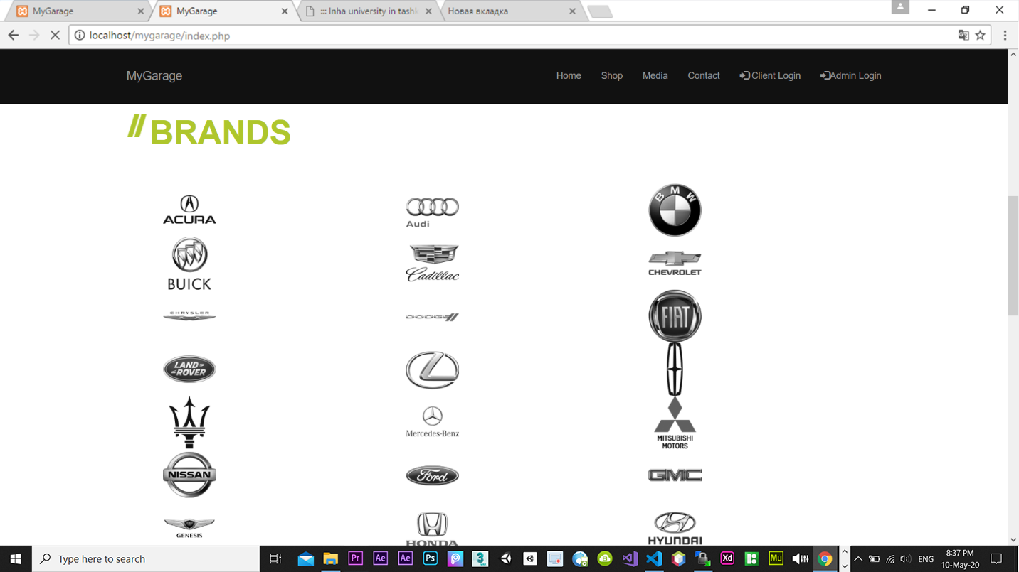

* At this picture, we just displayed different brands of cars

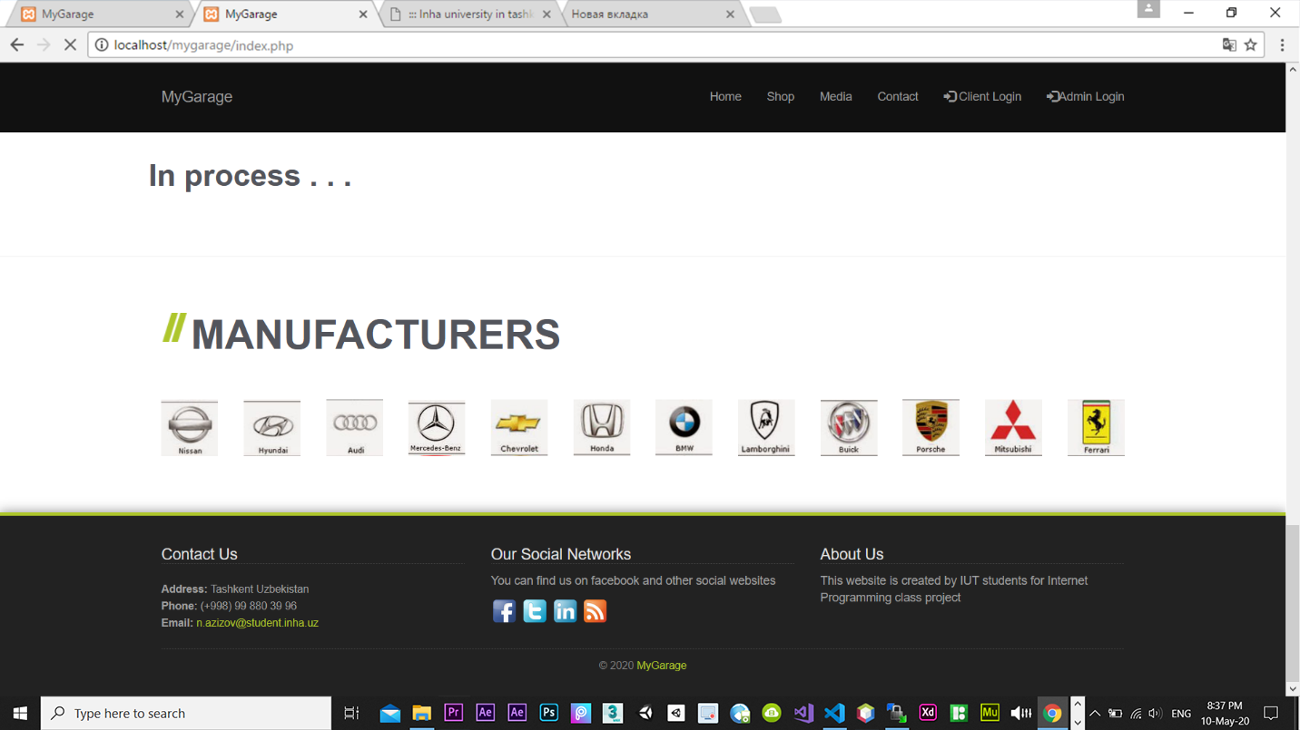

* In manufacturers section, there are brands we are working to
* And footer of the home page has ‘contact-us’ section where people who visited out web site can take contact numbers, can take an email of admin at INHA university and address - a region where our office is situated.
* **LOGIN & SIGN UP**
  + **SIGN UP**

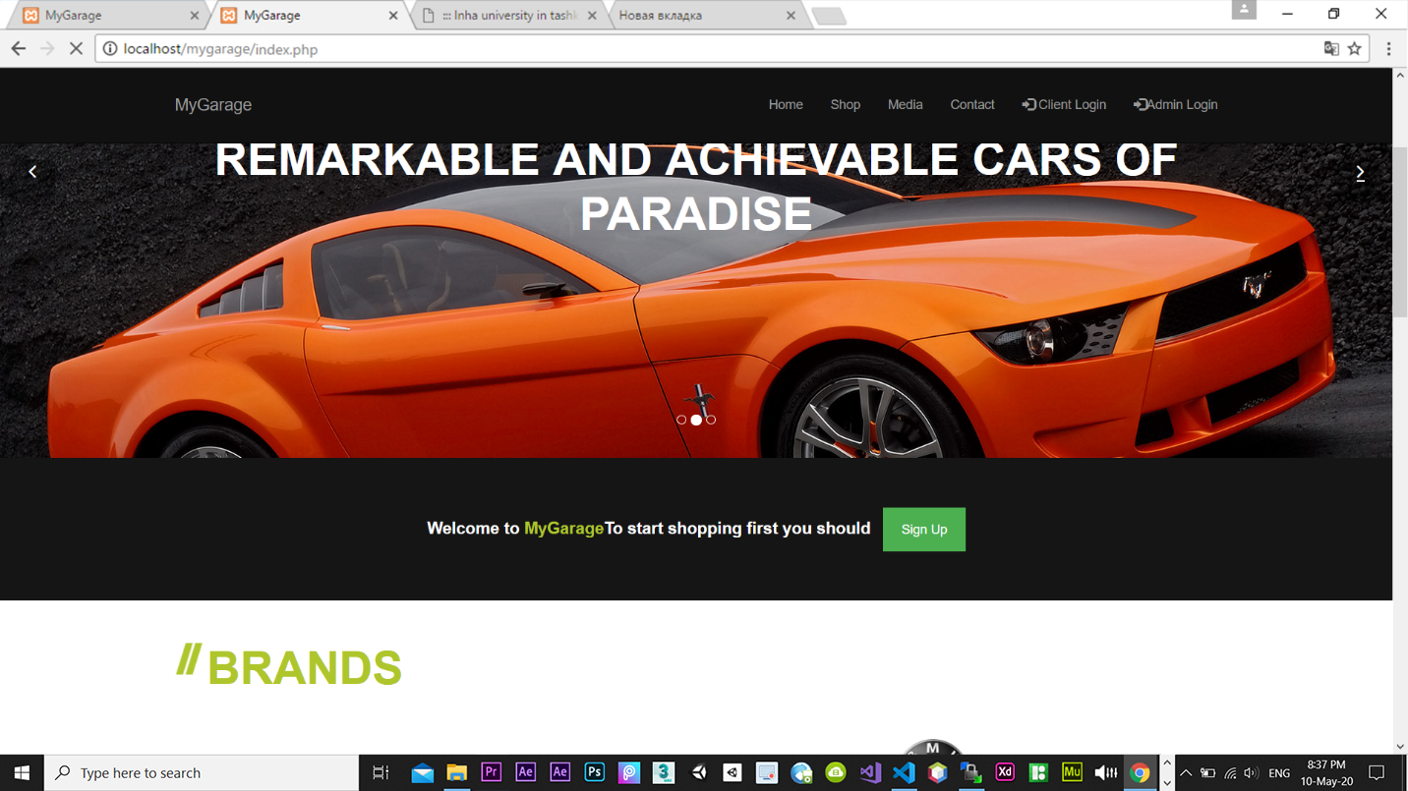

* We didn’t put our sign up button to the navbar at the top of our home page, we put it below of scrolling pictures as a result customers will look for this button and by scrolling page, the will take a view a little bit(which in fact they will remember);

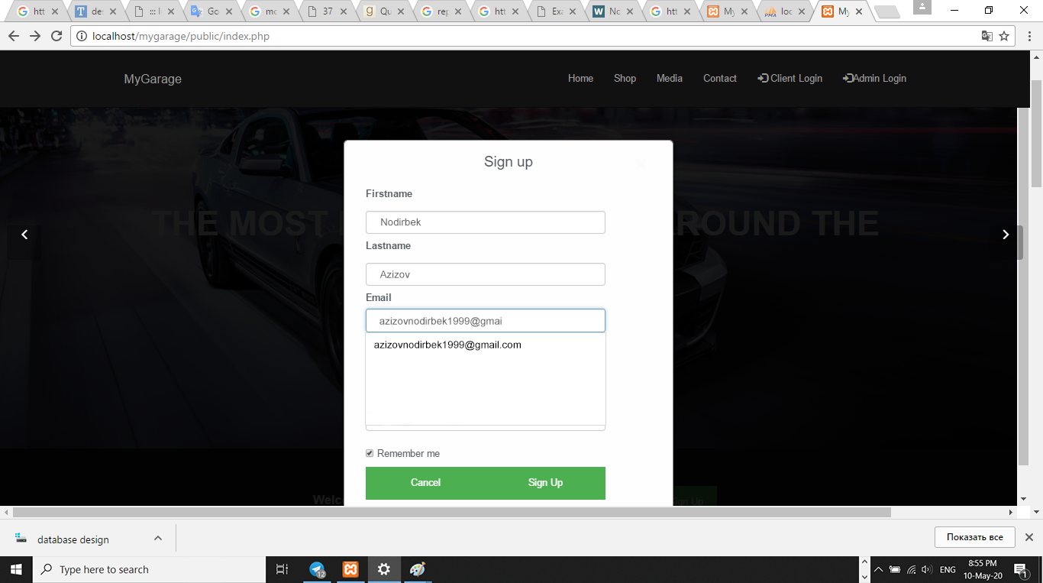

* Sign up table takes 3 inputs from users:
  + First name
  + Last name
  + Email (which will be used to sign in)

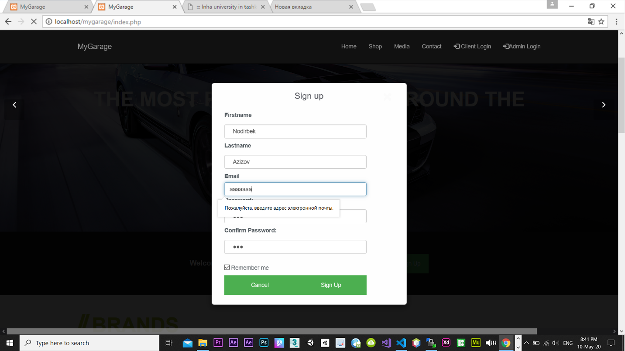

* Users cannot sign up with the wrong(not email) email.
* User can sign up with only …@gmail.com and @mail.ru
* We have used ‘session’ in our site, so It can remember user till he/she closes a browser
* If the user changed his mind and doesn’t want to sign up, it can click on the ‘cancel’ button or can just outside of the blank, it will close it.

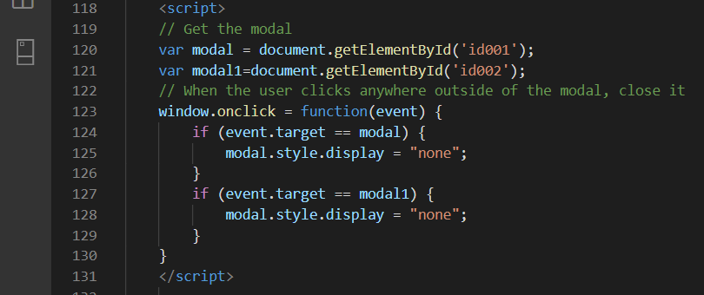

* + **LOGIN**
    - **Admin Login**

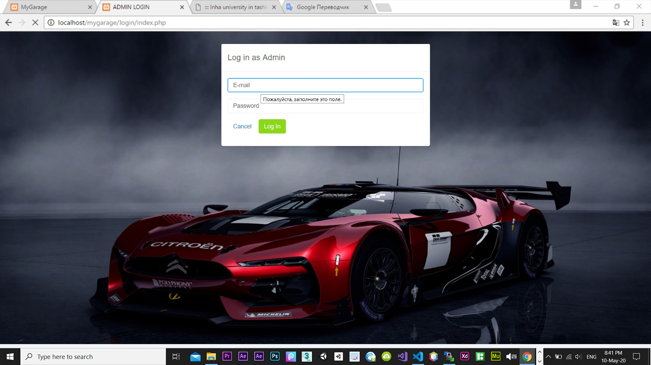

* In this page, Admin and Employee can enter to their accounts
  + Admin:
    - Email: [admin@admin.com](mailto:admin@admin.com)
    - password: admin
  + Employee
    - Email: [employee@employee.com](mailto:employee@employee.com)
    - Password: employee
    - **Client login**

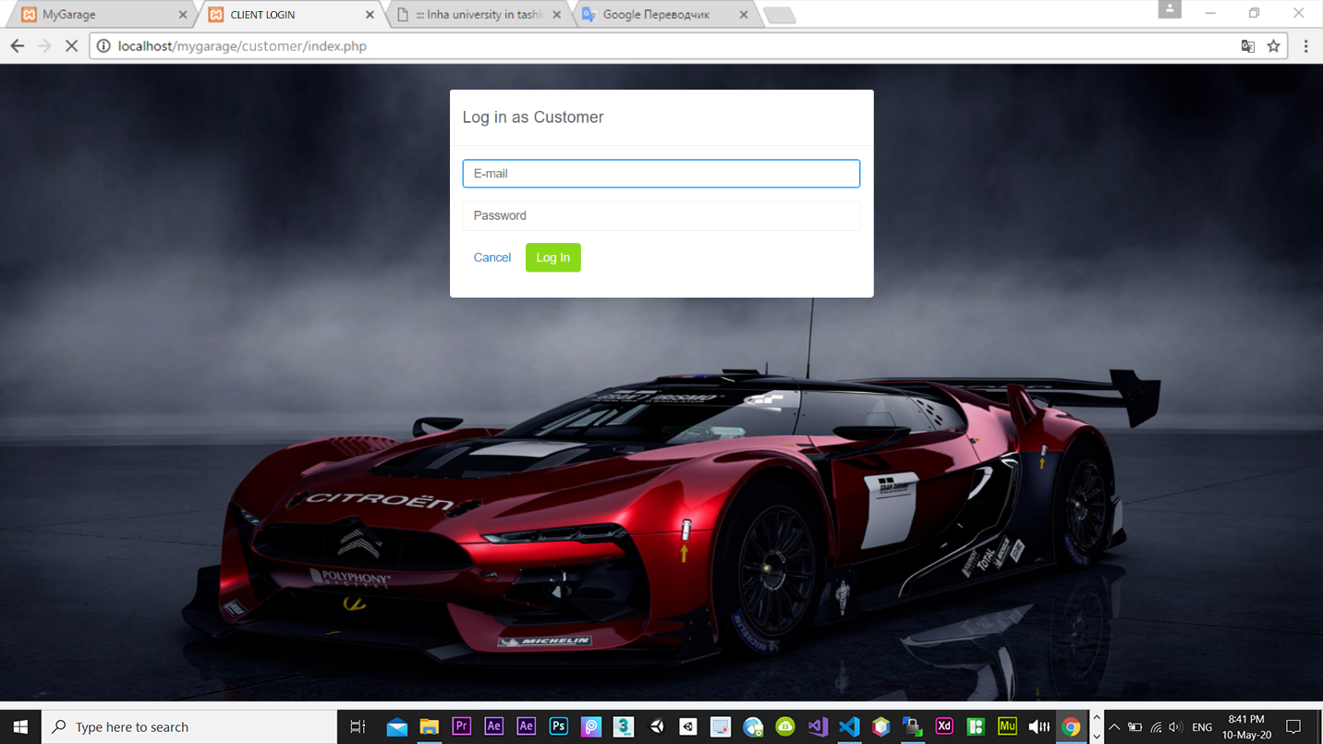

* In this page, Customers can enter to their accounts;
* **Admin’s page**
  + **Admin->dashboard**

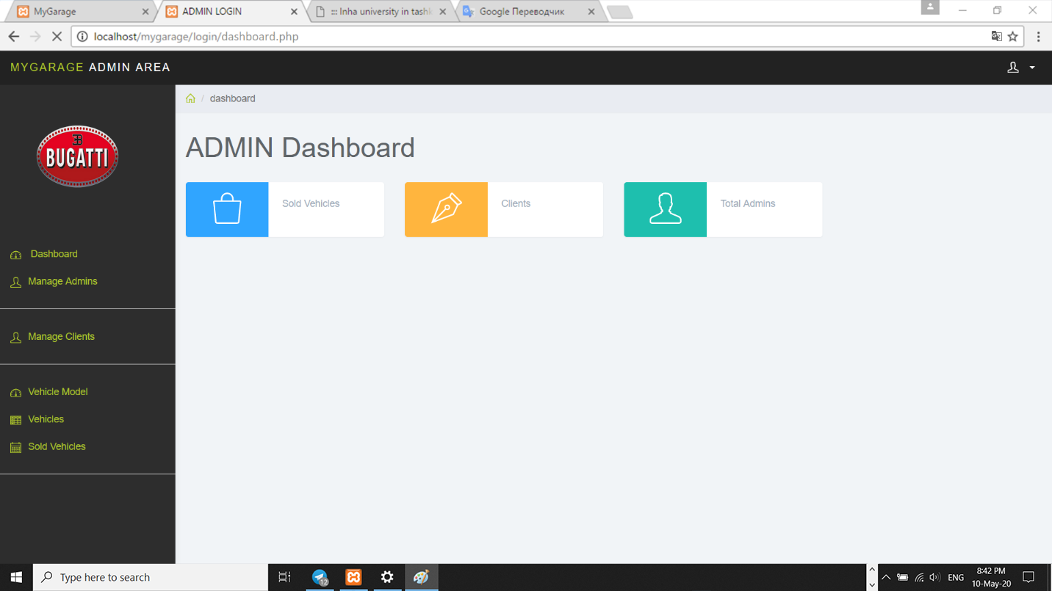

* In ‘Sold Vehicles’, Admin and employees can view sold vehicles;
* In ‘Clients’ Admin and employees can view a list of Clients;
* In ‘Total Admins’, admin and employees can see list of admin and workers of the web page
  + **Admin->Manage Admins**
* In this section, Admin can remove his/her employees
* Also, he/she can create employee directory for new workers and disturb it to them

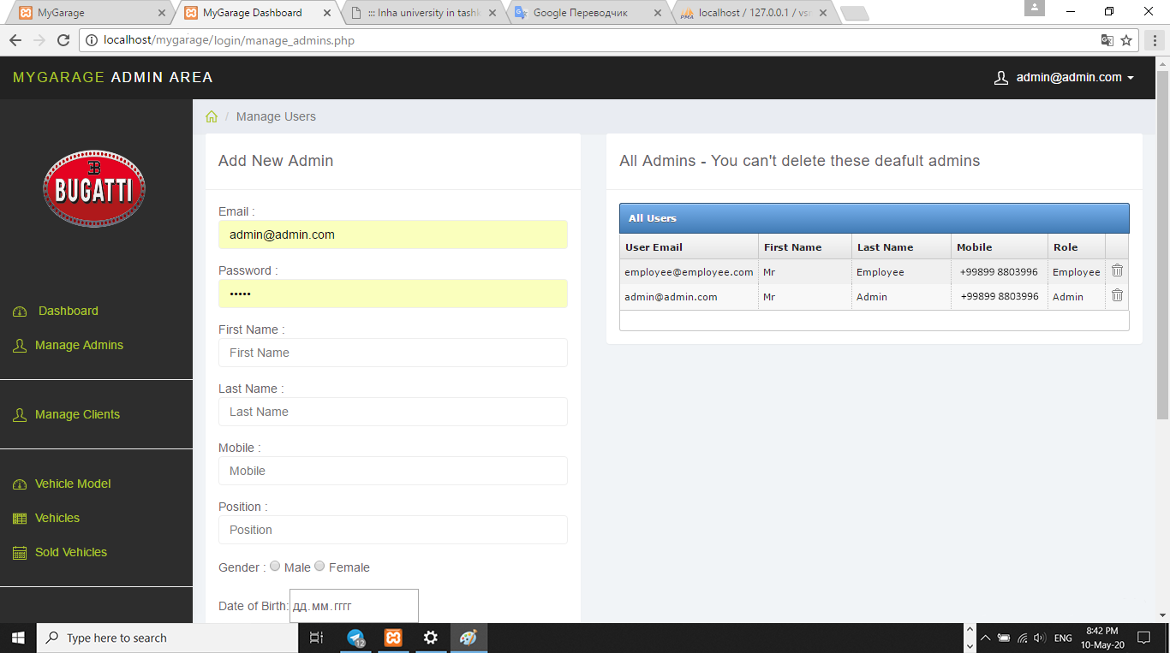

* + **Admin -> Vehicles**

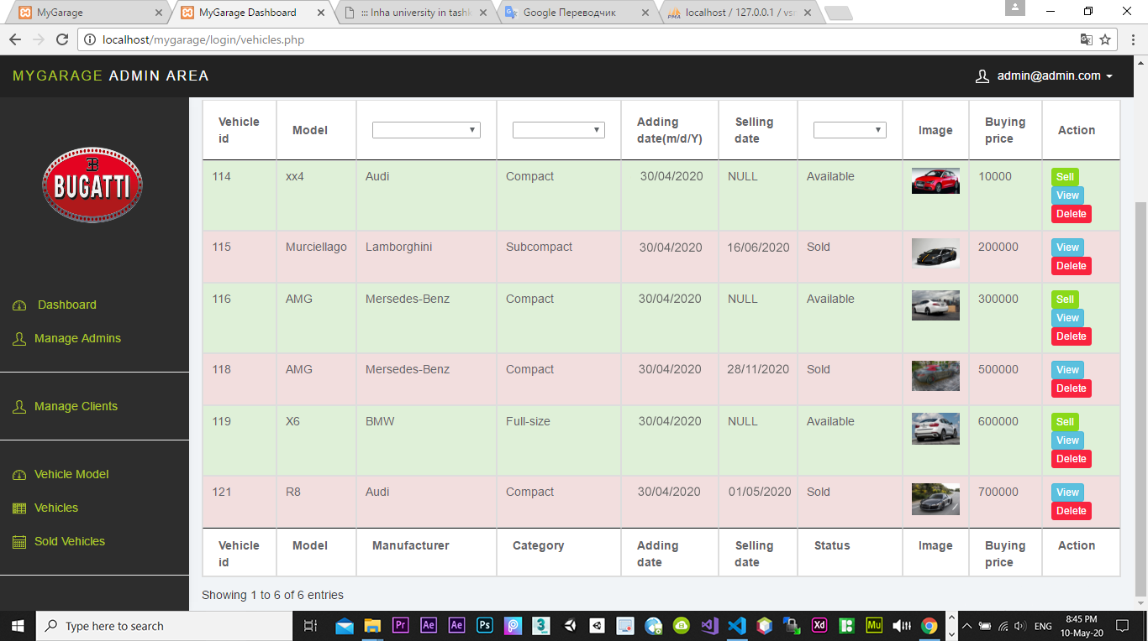

* In this page, admin can see the list of vehicles in the store, and their status whether they are sold or in sell



* Admin can also sort them by manufacturer name, category, Status (sold or in the sale)

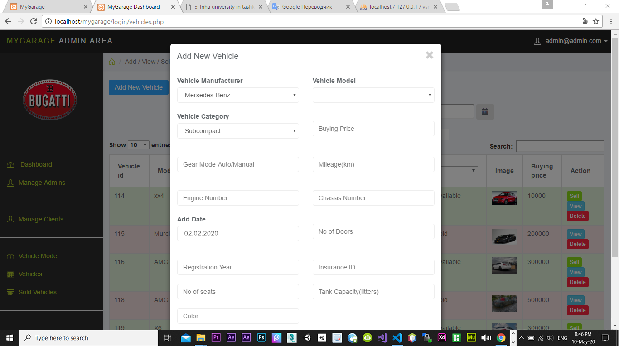

* Also, admin can add new cars filling blanks

**Now let’s look at other menus of our nav bar**

* **Shop**
* This menu is accessible for anybody who visits our web site

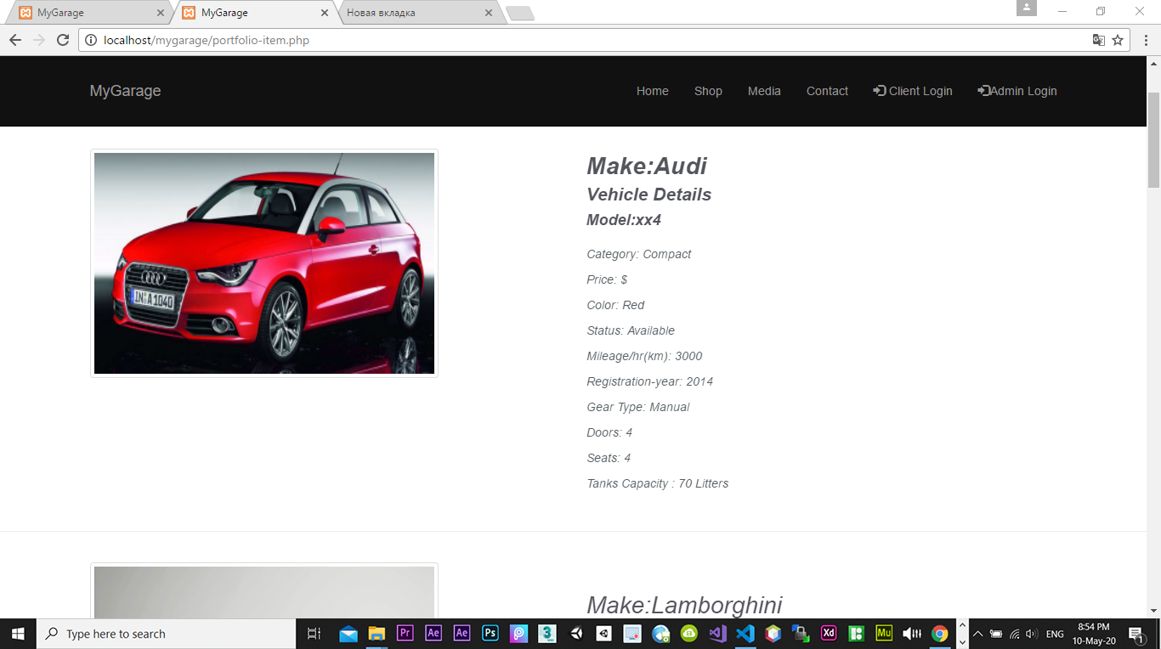

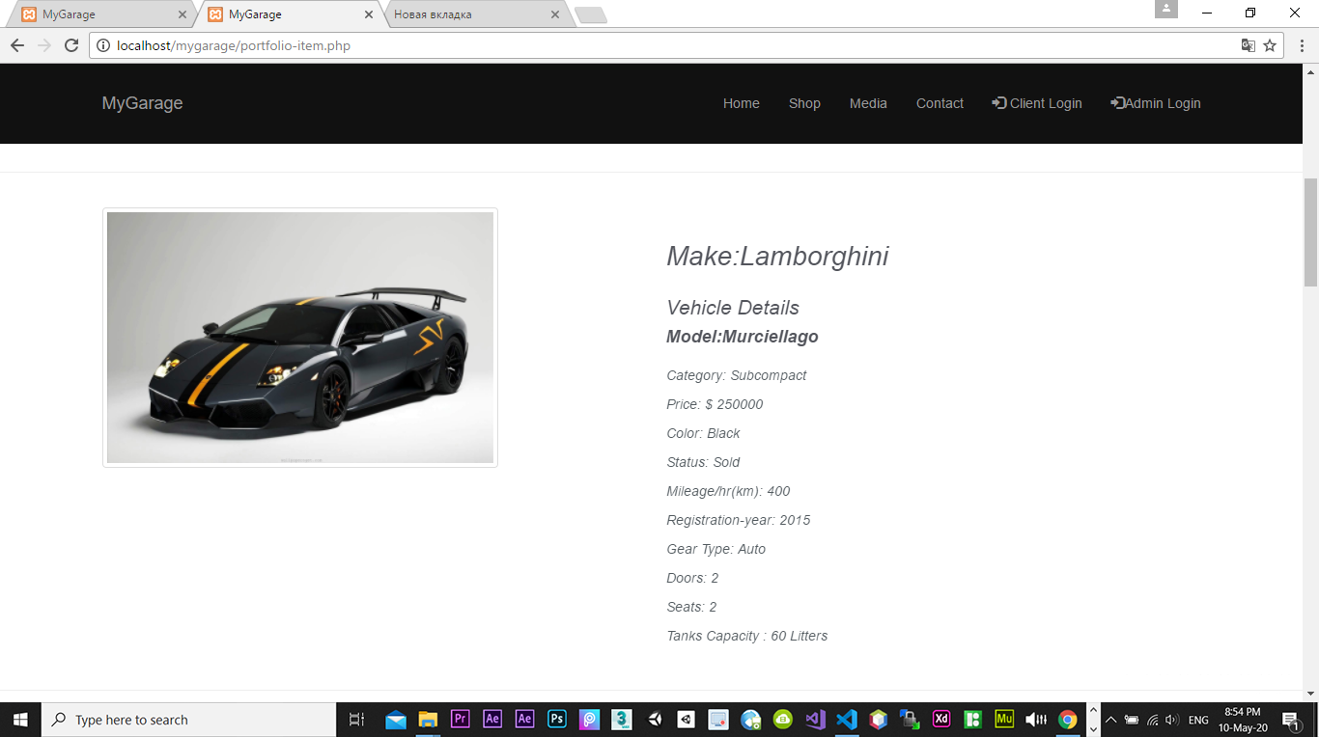

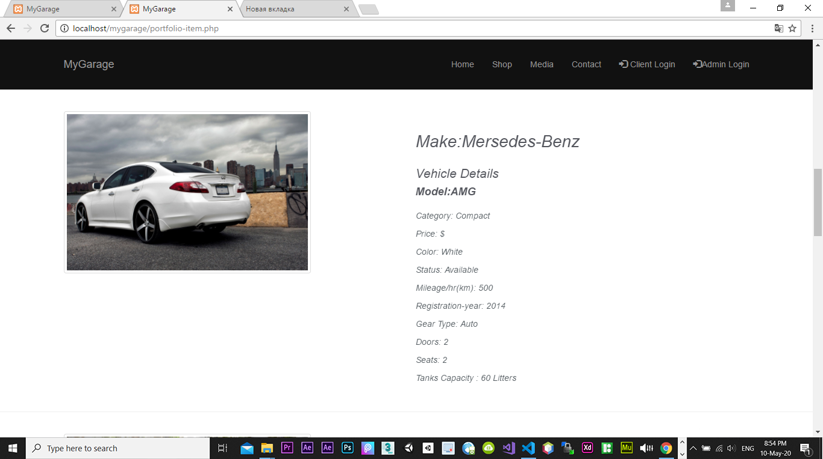

* As you can see, this page of our web site informs the visitor about vehicles in our store
* Visitors will find out all necessary information about the vehicle which they are interested in:
  + Model
  + Category
  + Price
  + Color
  + Status (whether sold or in the sale)
  + Mileage
  + Registration year
  + Gear type
  + Tanks capacity

And the interesting fact that they also are informed about the number of doors and sets, which we hope will help them in doing the right decision. For instance, for a big family buying compact cars is not a good idea, or for sports car lovers, we recommend buying a compact one.

* This page has not got a lot of functions, but it does its job
* Media
* Media is one of an important part of our web page;
* In the media page, users can find out the background of the great vehicles in the world;
* The main usage of this page is to interact visitor and make them be our clients;
* Also, people sometimes feel a little bit laziness to look for information of background of vehicles;
* So, our media page makes this job for them, they find short and necessary descriptions of our products;

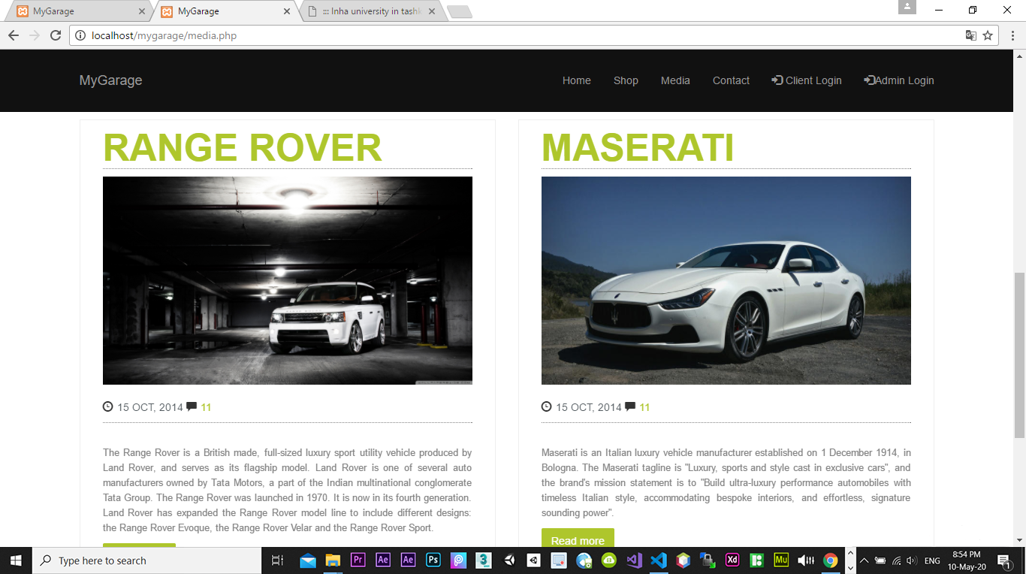

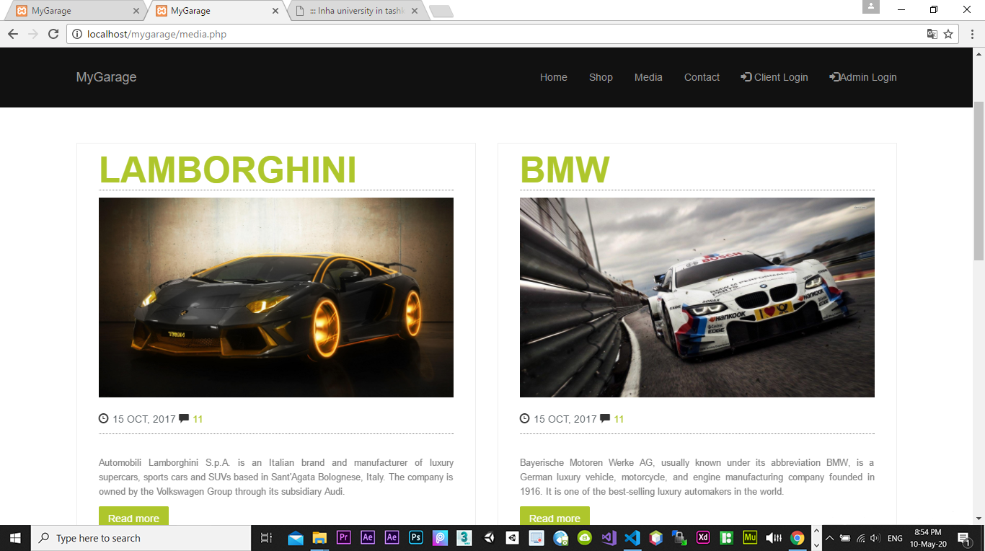

* Also, at the below of every picture of a car, by clicking comments icon, users can leave their comment about a particular car or read comments of other users;
* If users are really interested in about the background of a car, they can take that information by clicking the button ‘Read more’
* Contact

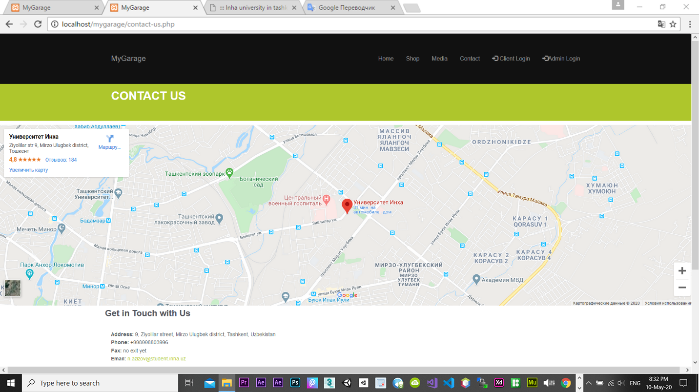

* This page is created to inform users about the legacy of our store
* They are being informed about the place where they can find us from iframe of google map
* Also, they will have a phone of admin to get in touch
* Also, there is an email of admin to which they can write

And Finally, Database

* **Database Table Diagram**

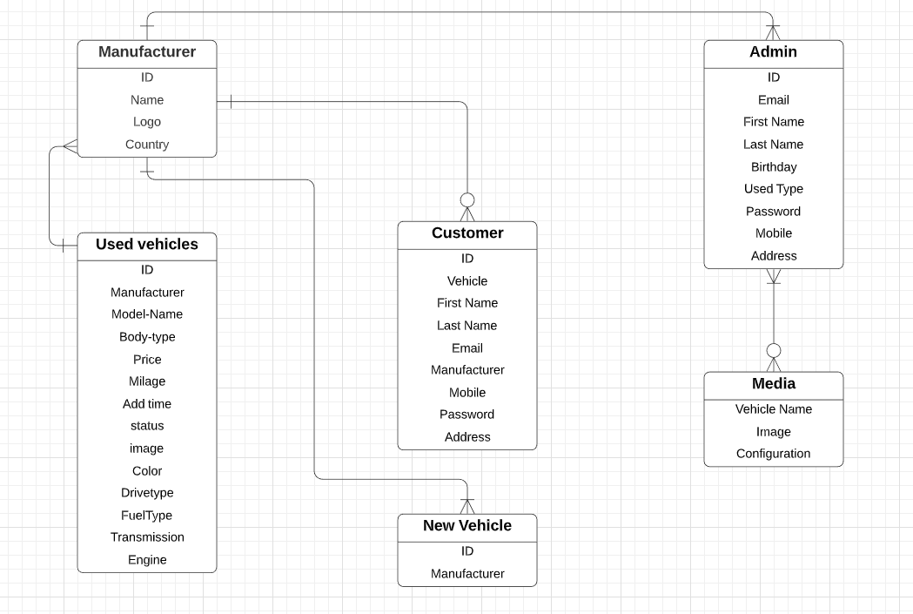

* A manufacturer can have one or multiple admins (and employees);
* A manufacturer can have none or many customers;
* A manufacturer can create one or multiple new vehicles which will be added by Admins to the web page;
* Vehicles can be from different manufacturers;
* Admin can edit(create/remove) media of a web page;

* Weak points of our project
* Not all input validations were covered, numbers can be as name of a user;
* Filters are not working yet;
* Comment button in media page is in the process;
* We wanted to create a page for ‘Read more’ button in media page, so they are not working now
* In ‘Admin Dashboard’ – ‘Sold vehicles’, ‘Clients’, ‘Total admins’ are not working yet

We have these issues because of our bad, late start.

Reference:

Github: <https://github.com/iuthub/ip-group-project-secret>